Introduction to Electrical Engineering

Assignment #8

Javier Jesús Macossay-Hernández

Student ID: #20228488

Tuesday, March 5, 2013

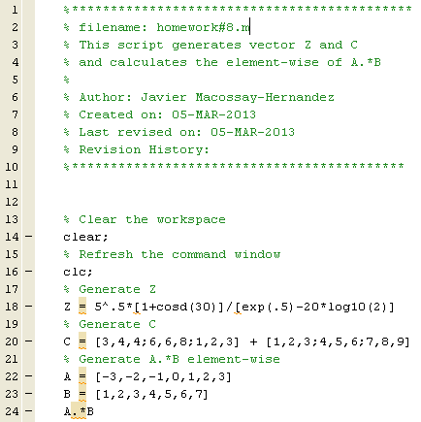

Problem #1

Open a MATLAB Edit window and type the MATLAB statement that calculates Z given by:

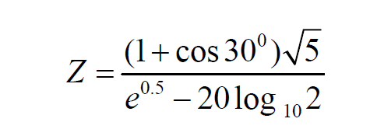

MATLAB Script:



Results obtained in the MATLAB Command Window:

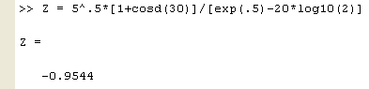

Problem #2

Open a MATLAB edit window and type the proper MATLAB statements to calculate the matrix C given by:

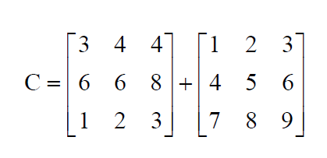

MATLAB Script:



Results obtained in the MATLAB Command Window:

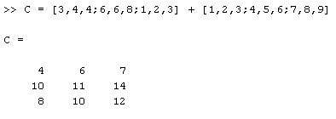

Problem #3

Build a MATLAB script that calculates the element-wise product of the following two numerical row vectors.

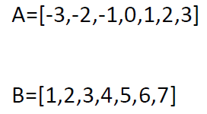

MATLAB Script:

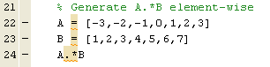

Results obtained in the MATLAB Command Window:

